Continuity of Learning - Part 1
Name: |  | Group:

The purpose of this block of learning is to try to get you grounded in the basics of Science & Principles as they apply to electrical installation, so that you should be capable to progress with the rest of unit 08 up to Level 3. It covers: -
- Step1 The standard units (S.I.) of measurement used in electrical installation work
- Step 2 The mathematical principles which are appropriate to electrical installation work
- Steps3-5 The relationship between resistivity, resistance, voltage, current and power
As you progress through the workbook you will have been introduced to the term RESISTANCE, and it is this that you will study in depth and be able to understand and to explain as an electrical property.
This sheet contains a study plan with Steps that must be followed in the order laid out; skipping steps or undertaking them in the wrong order will not help at all.
References for study including Text Bookand YouTube video links, are shown below each answer box.
There are separate worksheets and resources to supplement the questions within this workbook if you need further practice in any particular area.
Step 1
- Based on what you learnt (see references below), statefour of the seven Base S.I. quantities that are likely to be used in electrical installation work.
Base Quantity | Quantity Symbol | Base Unit | Unit Symbol
Length
 |  | kilogram
 |  |  | s
 |  |  | A
References:
- Text Book B Chapter ELTK 08 pages 212 – 213
- YouTube videos: Base SI units

- Based on other units derived from the seven base units, state fivederived S.I. quantities that are likely to be used in electrical installation work.
Base Quantity | Quantity Symbol | Base Unit | Unit Symbol
 |  |  | m²
 |  | volt
 | P
Resistance |  | Ohm
 |  |  | Hz
Resistivity |  | Ohm-metre
References:
- Text Book B Chapter ELTK 08 pages 212 – 213
- YouTube videos: Base SI units
Step 1 (continued)
- It is often more convenient to use multiples (or sub-multiples) of the units. Complete the table for theeightmultiples and sub-multiples that are used in electrical installation work.
Prefix | Prefix Symbol | Multiplier | As Power of 10
tera
 |  |  | 1 × 10⁹
 | M
 |  | × 1 000
 |  | × 1 | 1 × 10⁰
 |  | 0.001
 | μ
 |  |  | 1 × 10⁻⁹
pico
References:
- Text Book B Chapter ELTK 08 pages 214
- YouTube videos: Prefixes

- Some of the most commonly used Powers of 10 are shown below,complete the table for the
given examples of their typical use.
Example | Prefix Symbol | Multiplier | As Power of 10
1.5 mega-watts | MW | × 1 000 000 | 1.5 × 10⁶
16 milli-amps
400 kilo-volts
58 micro-farads
100 milli-henrys
16 milli-ohms
100 kilo-hertz
4.8 mega-joules
50 milli-metres | mm | × 0.001 | 50 × 10⁻³
500 milli-metres
30 micro-seconds
23 kilo-ohm
5.5 kilo-watts
References:
- Text Book B Chapter ELTK 08 pages 214, and 217-220
- YouTube videos: Prefixes

Step 2
Based on what you learnt about areas and volumes(see references below), calculate the following:-
- The cross-sectional areaof a section of 100mm x 75mm trunking.

- Express the answer to a) above in m².

- What is the cross-sectional areaof a circular solid conductor with a diameter of 5.64mm ?

- What is the cross-sectional areaof a circular stranded conductor with seven strands, each having a diameter of 1.05mm ?

References:
- YouTube videos: Circumference and Area cable CSA Area of a Rectangle

Problem solving is a skill that is needed to be able to find an unknown value when other values are known. However, just like fault-finding there is almost always a particular order that must be followed to get the correct answer.
Based on what you learnt about Algebra and Bidmas(see references below), calculate the following:-
- The value of R in the formula P = I R²when P = 4800, and I = 12

- The answer to 6 + 4 × 5

References:
- Text Book B Chapter ELTK 08 page 229
- YouTube videos: BIDMAS algebra

Step 2 (continued)
Transposition of formulae is another skill that is needed to be able to find an unknown value when other values are known.
Based on what you learnt about Transposition(see references below), rearrange the following:-
- Transpose (rearrange) the following formula to make R the subject: - V = I × R

- Transpose (rearrange) the following formula to make V the subject: - P = V × I

- Transpose (rearrange) the following formula to make I the subject: - P = I²× R

- Transpose (rearrange) the following formula to make R the subject: - Z² = X² + R²

References:
- Text Book B Chapter ELTK 08 pages232 - 234
- YouTube videos: Transposition Part 1 Transposition Part 2

Percentages are often needed in problem solving is a skill that is needed to be able to compare quantities with different units.
Based on what you learnt about Percentages(see references below), calculate the following:-
- 80% of 1.37?

- the percentage drop between 230 and 218.5?

References:
- Text Book B Chapter ELTK 08 pages225 - 228
- YouTube videos: Percentages Percentage change

Step 2 (continued)
Using right angled triangles to determine unknown electrical values is another skill that is needed to be able to find an unknown value when two other values are known.
Based on what you learnt about Pythagoras Theorem(see references below), calculate the following: -
- Calculate the value of x
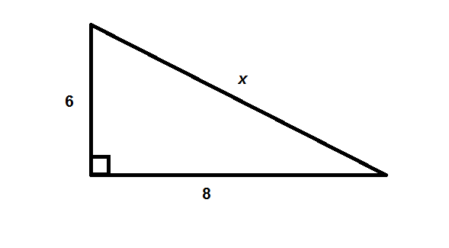
- Calculate the length of sideCA
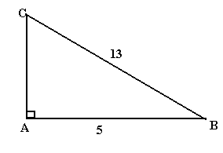
References:
- Text Book B Chapter ELTK 08 pages 236 - 237
- YouTube videos: Pythagoras

Based on what you learnt about Trigonometry(see references below), calculate the following:-
- Calculate the length ofx
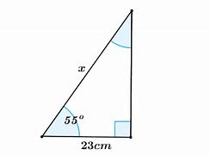
- Calculate the angle z
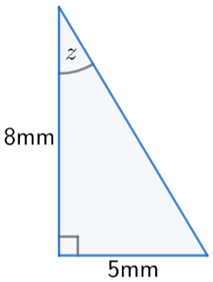
References:
- Text Book B Chapter ELTK 08 pages 237 - 240
- YouTube videos: Trigonometry introduction Trig missing sides Trig missing angles

Step 3
Have you ever wondered why some materials make good insulators and others make good conductors?
Based on what you learnt about Molecules and Atoms(see references below), answer the following: -
- What is the charge on a proton?

- What is the charge on an electron?

- State the overall charge of an atom and explain why this the case.

- With the aid of a simple diagram, show that a copper atom consists of 29 electrons, and how many electrons there are in its outer shell.
- What makes copper a good conductor?

References:
- Text Book B Chapter ELTK 08 pages 260 - 263
- YouTube videos: electrostatics structure of the atom structure of copper electric charge

What is it that causes the electrons in good conductors to suddenly start moving in the same direction, causing a current flow? Based on what you have learnt(see references below), answer the following: -
- Explain how are electrons made to flow in a conductor?

- Which direction do electrons flow in a d.c. circuit?

- What is meant by the term ‘conventional’ current which is opposite what we now know?

References:
- Text Book B Chapter ELTK 08 pages 265 - 266
- YouTube videos: electron flow
Step 4
In a similar way that all species have a different DNA structure, all conductors and insulators have a different ATOMIC structure which results in differentResistivities (ease of flow of its electrons).

- Explain what happens to all conductor’s resistance if you double its length?
- Explain what happens to all conductor’s resistance if you double its CSA?
- Which two of the following three conductor terms are said to be directly proportional?
RESISTANCE CROSS-SECTIONAL AREA (CSA) LENGTH
- How does temperature affect the resistance of a metal conductor?
- For a particular conductor material (e.g. copper) what three things will affect the resistance reading of the sample given?
References:
- Text Book B Chapter ELTK 08 page 271 - 272
- YouTube videos: Resistance &Resistivity 1 Resistance & Resistivity 2

Determine conductor resistance using materialResistivities(see references below), calculate: -
- The resistance of a 100m length of 2.5mm² copper conductor (ignore temperature).
(Show all formula, transposition and working out)(Use 17.2 × 10⁻⁹ Ohm-metre for Rho)

- The resistance of a 50m length of 6.0mm² copper conductor (ignore temperature).
(Show all formula, transposition and working out)(Use 17.2 × 10⁻⁹ Ohm-metre for Rho)
)

References:
- Text Book B Chapter ELTK 08 pages 273 - 275
- YouTube videos: Resistance & Resistivity 3 Calculating resistivity
Table I1 in the IET On-Site guide gives the value of 1 metre of 1mm²copper conductor as 18.10mΩ (milli-ohm).
You should now understand how this is arrived at using the Resistance/ Resistivity calculations.
Step 5
We have looked at Resistance and Resistivity in some detail. We will now seriously consider how this relates to Current, Voltage and Power, as this is what we are most likely to consider during electrical installation work. (see references below), calculate: -

- The total resistance of the following series connected resistors: 18 Ohm, 56 Ohm, and 120 Ohm.
(Show all formula, transposition and working out)

- The total resistance of the following series connected resistors: 18 Ohm and 56 KiloOhm.
(Show all formula, transposition and working out)

- The current that would flow through an 18 Ohm resistor connected across a 18-volt d.c. supply.
(Show all formula, transposition and working out)

- The value of resistor that when connected across a 20-volt supply, would cause a current of 2 amps to flow.
(Show all formula, transposition and working out)

- The voltage that would cause a current of 11.5 amps to flow through a 20 Ohm resistance.
(Show all formula, transposition and working out)

References:
- Text Book B Chapter ELTK 08 pages 276 - 277
- YouTube videos: Introduction to series resistance Series circuit Ohm's Law

Step 5 (continued)
Twoseries connected resistors of 8 Ohm and16 Ohm are connected across a 12 voltd.c. supply.
Calculate: -

- the total circuit resistance (R_{T})
(Show all formula, transposition and working out)

- the circuit current (I)
(Show all formula, transposition and working out)

- the voltage drop across the 8 Ohm resistor (V_{R1})
(Show all formula, transposition and working out)

- the voltage drop across the 16 Ohm resistor (V_{R2})
(Show all formula, transposition and working out)

- The power dissipated by the 8 Ohm resistor (P_{R1})
(Show all formula, transposition and working out)

- The power dissipated by the 16 Ohm resistor (P_{R2})
(Show all formula, transposition and working out)

References:
- Text Book B Chapter ELTK 08 pages 277 and 284
- YouTube videos: Resistive Power Power formula Voltage drop

Step 5 (continued)
Twoparallel connected resistors, both of 8 Ohm are connected across a 12 voltd.c. supply.Calculate: -

- the total circuit resistance (R_{T})(Show all formula, transposition and working out)

- the total circuit current (I)(Show all formula, transposition and working out)

- The power dissipated in each of the 8 Ohm resistor (P)(Show all formula, transposition and working out)

References:
- Text Book B Chapter ELTK 08 pages 278 - 279
- YouTube videos: Parallel Resistors Parallel Resistor Formula

Three resistors of 12, 18 and 27 Ohm are connected in parallel across a 24 voltd.c. supply.Calculate: -
- the total circuit resistance (R_{T})(Show all formula, transposition and working out)

- the total circuit current (I)(Show all formula, transposition and working out)

- The power dissipated in the 12 Ohm resistor (P_{R1})(Show all formula, transposition and working out)

References:
- Text Book B Chapter ELTK 08 pages 278 – 279, and 283
- YouTube videos: Parallel Resistors Parallel Resistor Formula
Step 5 (continued)
A 230v electric shower has a total heating element resistance of 6.22 Ohm.

- Calculate the current that will flow.
(Show all formula, transposition and working out)

References:
- Text Book B Chapter ELTK 08 page 284
- YouTube videos: Resistive Power Power formula

The shower in r) above, is supplied by a cable that has a total conductor resistance of 0.19 Ohm.

- Calculate the voltage drop that will occur along the length of the cable.
(Show all formula, transposition and working out)

References:
- Text Book B Chapter ELTK 08 pages 277 and 282
- YouTube videos: Power formula

- Determine if thevoltage drop in s)above, is within the acceptable limits set out in BS7671.
(Show all formula, transposition and working out)

References:
- Text Book B Chapter ELTK 08 page 282
- YouTube videos: Voltage drop in circuits

- Explain whyvoltage drop should be considered and factored in to electrical circuit design.

References:
- Text Book B Chapter ELTK 08 page 282
- YouTube videos: Voltage drop in circuits

