Electrical Science and Principles - Workbook 2
Name: |  | Group:

The purpose of the last block of learning which included Workbook 1, was to try to get you grounded in the basics, so that you should be capable to progress with the rest of the unit 08.
As you progressed through the set tasks you will have been introduced to the term REACTANCE, and it is this that you will now study further and be able to understand and to explain this electrical property.
This sheet contains a study plan with Steps that must be followed in the order laid out; skipping steps or undertaking them in the wrong order will not help at all.
References for study including Text and YouTube video links, are shown below each answer box.

Step 1
Based on what you learnt in the last block of learning, explain why the current in an a.c. circuit is continuously changing (i) in magnitude AND (ii) in direction of flow.
References:
- Text Book B Chapter ELTK 08 pages 304 – 305
- YouTube videos: ac fundamentals ac generator

Step 2
The following graph (normally referred to as a Sine Wave), is showing 1 cycle of an a.c. generator.
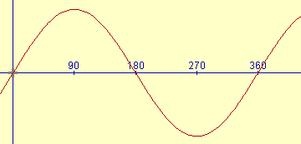

Step 2 (continued)
The following five questions relate to this single-phase ac generator as used in the UK:
- How many degrees does a coil have to rotate in an a.c. generator to complete 1 cycle?

- In the UK how many cycles does the a.c. generator complete in 1 second?

- How would the number of cycles per second be indicated on an ac generator (number and unit)?

- What speed in RPM (revolutions per minute) would the generator be rotating at?

- What is the peak voltage produced from an a.c. generator at the 90^{O} and 270^{O} sine wave points?

References:
- Text Book B Chapter ELTK 08 pages 312 - 314
- YouTube videos: Understanding RMS and PEAK

Step 3
Heating elements are often referred to as Purely Resistive loads (cookers, heater, showers, etc)
Consider the following immersion heating element connected to a 240 V supply.
Explain, if any, what would be the difference if the heating element was connected to a 240V d.c. supply than if it was connected to a 240V a.c. supply?
References:
- Text Book B Chapter ELTK 08 page 314
- YouTube videos: ac V dc Difference rms ac ac vs dc

Step 4
Coils of conductor are often referred to as Inductors or Inductive loads (transformers, motors, chokes, etc), and they do something quite extra ordinary when connected to only an a.c. supply.
- Explain what happens inside an inductor (coil) when a voltage to it is first switched on, and then what happens inside the inductor when the voltage is switched off.
References:
- Text Book B Chapter ELTK 08 page 317
- YouTube videos: Inductors explained

- What type of electricity supply has the voltage ‘switching’ on and off continuously?

Step 4 (continued)
The following questions are based on a single transformer coil (as in the video below) which has a natural resistance of 53 Ohm. Be clear, this 53 Ω of resistance cannot change, as it is based on the material (copper), its length, and its cross-sectional area.

- Calculate the current that will flow in to the transformer coil when it is connected to a 53V d.c. supply.
Show all your working out.
References:
- Text Book B Chapter ELTK 08 pages 317 – 319
- YouTube videos: Inductive reactance explained

Step 4 (continued)
- When the open transformer coil is then connected to a 53V a.c. supply, what current flows.

- By applying Ohm’s Law to the a.c. current in 4d) above, calculate what the Ohms value of the circuit must be when connected to the a.c. voltage.
Show all your working out.

- Does the current through the transformer coil increase or decrease when connected to an a.c. supply?

- In YOUR OWN WORDS, but including the following six terms, explain why the current changes in the way you answered it in f) above:

Inductor Inductive reactance Inducing moving magnetic field

opposing (bucking) counter electromotive force

Step 4 (continued)
- Show the formula that allows you to calculate the extra OHMs that an inductor will produce when connected to an a.c. supply, and provide details of all the units in the formula.
References:
- Text Book B Chapter ELTK 08 pages 318
- YouTube videos: Inductive reactance explained

- A coil of 0.25 Henry is connected across a 230 V 50 Hz supply. Calculate the inductive reactance produced by the coil
Show all your working out.
References:
- Text Book B Chapter ELTK 08 page 323
- YouTube videos: Inductive reactance formula

- For the question above, which of the following electrical quantities DO NOT make any difference whatsoever to the inductive reactance produced by the coil?

Inductance (0.25 H) Voltage (230 V) Frequency (50 Hz)

- A coil of 150 mH is connected across a 110 V 50 Hz supply. Calculate the inductive reactance produced by the coil
Show all your working out.

Step 4 (continued)
- In the symbol X_{L}
What does the X stand for?

What does the _{L} stand for?

Step 5
When the length of copper conductor is wound in to produce the transformer coil (as in the video demonstration) the conductor doesn’t suddenly lose it’s 53 Ω of resistance, it can’t suddenly disappear. What happens is that, when it is connected to an a.c. supply, some additional ‘resistance’ appears as a reaction to the a.c. supply.
In order to show both the natural resistance and the created reactance in a diagram, the coil is often drawn like:
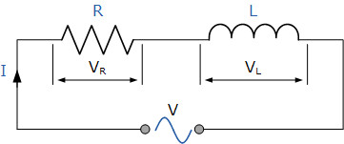
Note: |  | is now used rather than the older symbol | 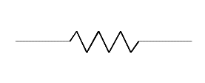

- What does the symbol R represent of the coil, and what are the units measured in?
References:
- Text Book B Chapter ELTK 08 pages 323 - 324

- What does the symbol L represent of the coil, and what are the units measured in?
References:
- Text Book B Chapter ELTK 08 pages 323 - 324

Step 5 (continued)
- A 132.6 mH transformer winding has a resistance of 120 Ω and is designed to be connected to a single-phase 240 V 50 Hz supply.
Produce a diagram like the one at the beginning of Step 5, and label it with the following:
R L V_{s} f 120 Ω 132.6 mH 240 V 50 Hz

References:
- Text Book B Chapter ELTK 08 pages 323 - 325
- YouTube videos: Calculate Inductive Reactance & Impedance

- Calculate the inductive reactance produce by the transformer winding.
Show all your working out.

References:
- Text Chapter ELTK 08 pages 323 - 325
- YouTube videos: Calculate Inductive Reactance & Impedance

- Explain why you cannot just add the Inductive Reactance (X_{L}) OHMs to the Resistance (R) OHMs to get the overall Impedance (Z) OHMs in other words Z = R + X_{L}
References:
- Text Book B Chapter ELTK 08 pages 323 - 324
Step 5 (continued)
- Combine the inductive reactance and resistance to calculate the Impedance of the transformer winding when connected to a single-phase 240 V 50 Hz supply.
Show all your working out.

References:
- Text Chapter ELTK 08 pages 323 - 325
- YouTube videos: Calculate Inductive Reactance & Impedance

- Produce an Impedance triangle that shows the Impedance, Reactance, Resistance of this circuit.
References:
- Text Chapter ELTK 08 pages 323 - 325
- YouTube videos: Calculate Inductive Reactance & Impedance

Step 5 (continued)
- Calculate the current that would flow through the transformer winding when it is connected to a single-phase 240 V 50 Hz supply.
Show all your working out.

References:
- Text Chapter ELTK 08 pages 323 - 325
- YouTube videos: Calculate Inductive Reactance & Impedance

- Calculate the voltage that would be across the Resistive part of the circuit (V_{R})
Show all your working out.

References:
- Text Chapter ELTK 08 pages 323 - 325
- YouTube videos: Calculate Inductive Reactance & Impedance

- Calculate the voltage that would be across the Reactive part of the circuit (V_{L})
Show all your working out.

References:
- Text Chapter ELTK 08 pages 323 - 325
- YouTube videos: Calculate Inductive Reactance & Impedance
Step 5 (continued)
- Explain why the voltage across the resistive part (V_{R}) and the voltage across the reactive part (V_{L}) do not add up to the supply voltage (V_{S}) in other words V_{S} = V_{R} + V_{L}
References:
- Text Chapter ELTK 08 pages 323 - 325
- YouTube videos: Calculate Inductive Reactance & Impedance

- When this transformer is connected to a 240 V 50 Hz supply, explain what is meant by its power factor (pf)
References:
- Text Chapter ELTK 08 pages 317 - 319
- YouTube videos: Calculate Inductive Reactance & Impedance

- Calculate the power factor of the circuit (p.f.)
Show all your working out.

References:
- Text Chapter ELTK 08 pages 323 - 325
- YouTube videos: Calculate Inductive Reactance & Impedance
Step 6

Now that you have worked through an example of an inductor impedance calculation, the following is aimed at seeing if you can undertake the same again, but for a different coil.

The following questions are based on the main winding of a single-phase induction motor.

The motor nameplate details include: -

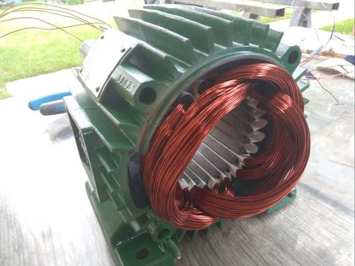 | Nameplate details:  Voltage 230 Volt  Frequency 50 Hz  Coil resistance 12 Ohm  Coil inductance 20mH

For this motor winding calculate:
- The Inductive Reactance
- The Impedance
- The current
- The voltage across the resistance
- The voltage across the reactance
- The power factor

Show all your working out.

Step 6 (continued)

Show all your working out.

