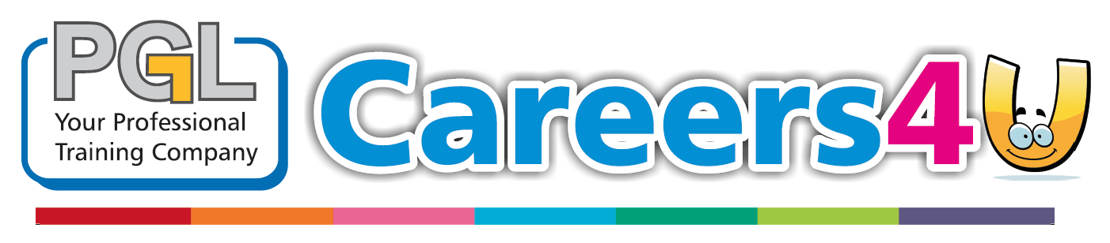

**SATURDAY OPENING**

**October 2018**

**NEWSLETTER**

**TRAINEESHIP ALERT**

January 2018

**MONTHLY NEWSLETTER**

**Would you like FREE Advice and Guidance about our courses but can’t spare any time Monday- Friday? How about coming to see us on a Saturday instead? We have confirmed the date for our next opening. PGL Careers4U will be open on Saturday 24th November 2018. Contact our dedicated Recruitment team to secure your slot today on 01392 537561.**

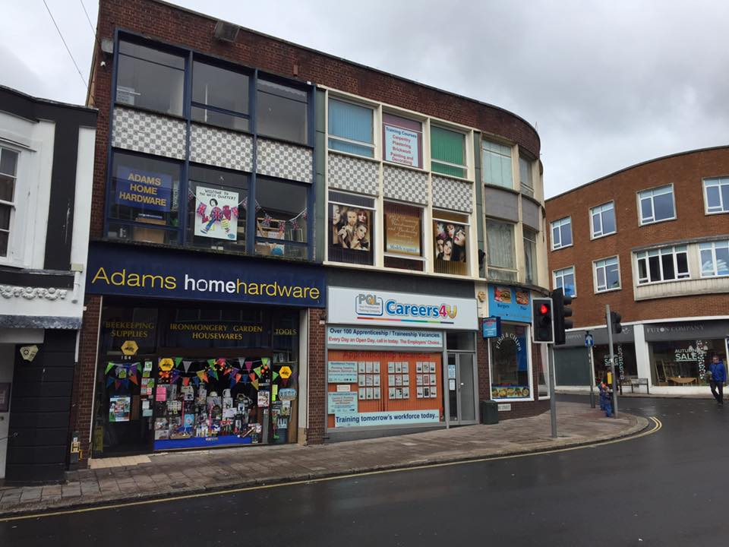

**Our Traineeship scheme is designed to help young people gain the skills required for an apprenticeship and find a placement. The course also offers learners the opportunity to complete Functional Skills maths and English along with employability skills.**



**PGL Training has just signed up for our first event, a 5km Glow in the Park fun run to raise money for the Mind Charity. Mental health is really important and affects so many people; we are raising awareness and crucial funding with the aim of raising a massive £20,000 by March 2019. We do need more help though and will be gratefully accepting online and cash donations using the link below-**<https://www.justgiving.com/crowdfunding/pgl-training-4>

**PGL Training will be introducing new qualifications in January 2019. PGL Training is already offering new apprenticeships in Groundwork and Flooring. Contact the apprenticeship Recruitment team today- 01392 537561**

**PGL Hair4U in Exeter city centre opened for business on Monday 22nd October 2018. We welcomed a number of learners and clients to the salon this week. Until our event on the 29th March 2019, all revenue from the Hair4U academy salon will be donated to the Mind Charity. For more information please contact the Recruitment team today- 01392 537561. Hair4U will be offering different courses in Hairdressing and Barbering. Pop in to the salon to have a look.**

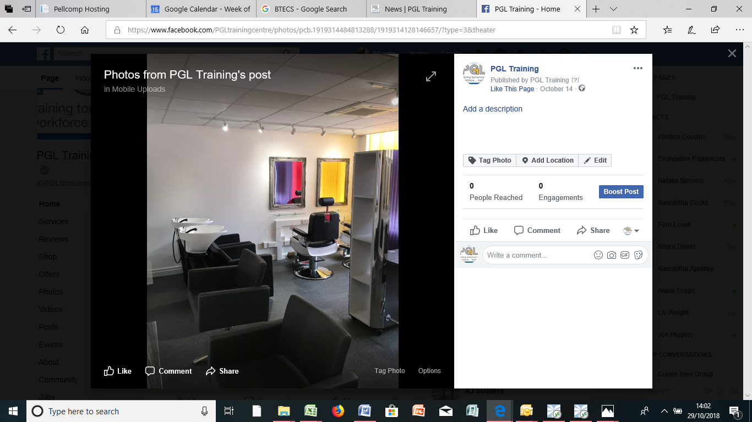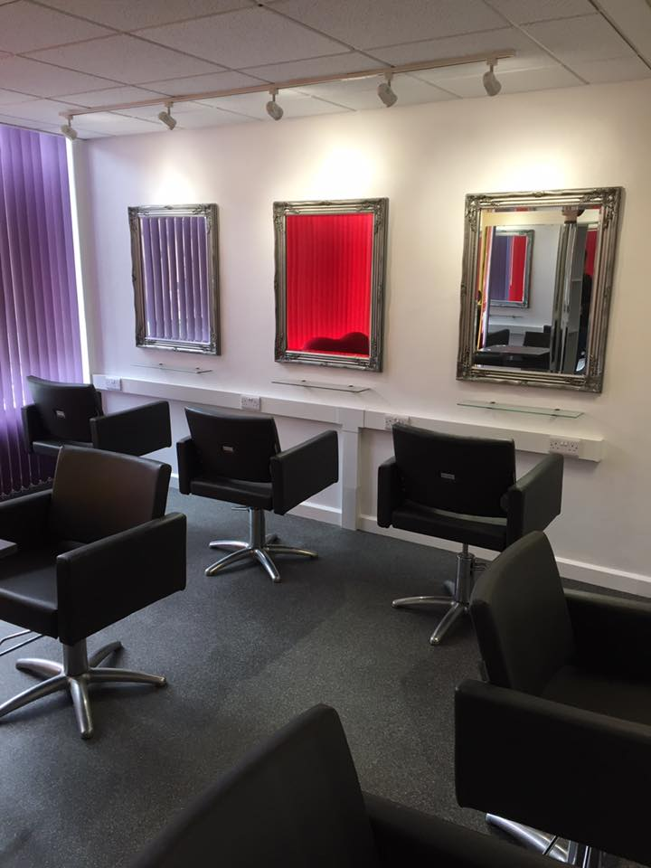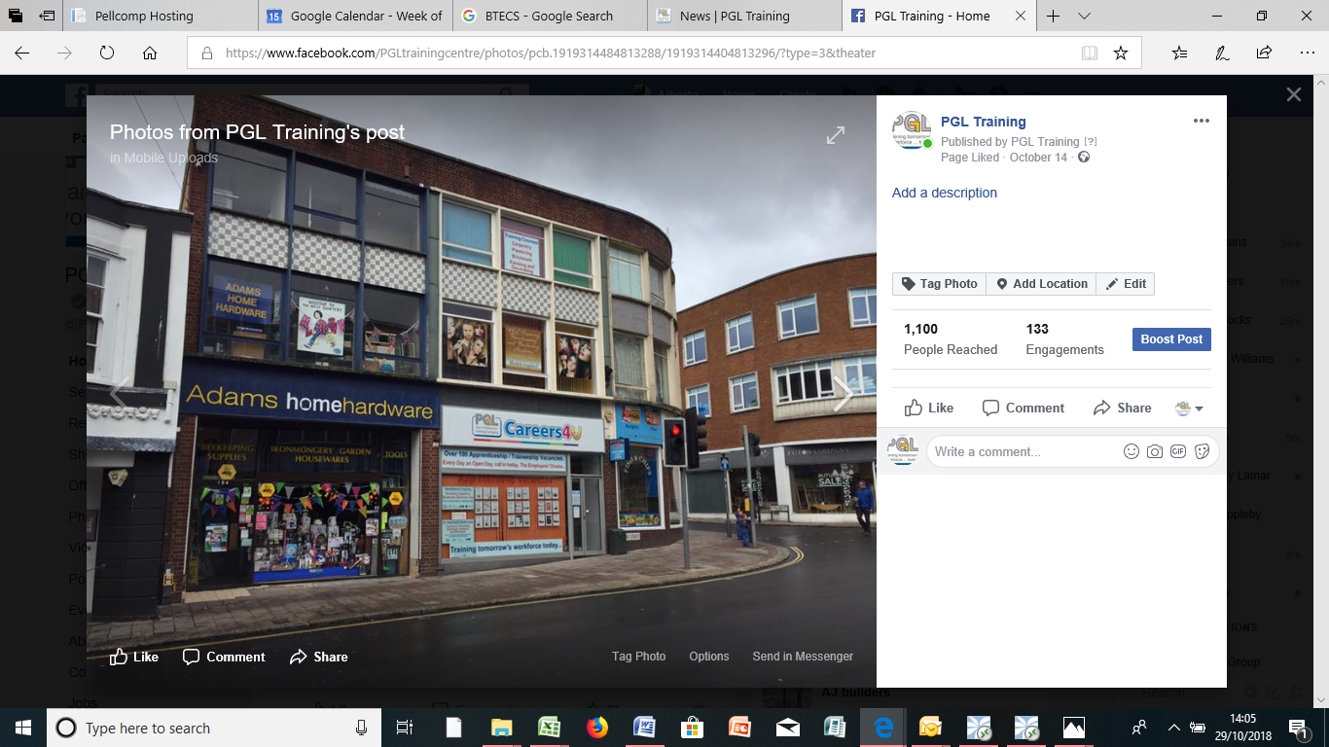

**NEW QUALIFICATIONS**

**TASTER DAYS**

**HAIR4U- PGL TRAINING (FORE STREET)**

**GLOW IN THE PARK**

**Would you like to complete a taster day in our amazing workshops in Construction, Plumbing, Business Admin, Hairdressing and Electrical? We have various dates and times throughout November and December, contact the Recruitment team today for more information- 01392 537561.**