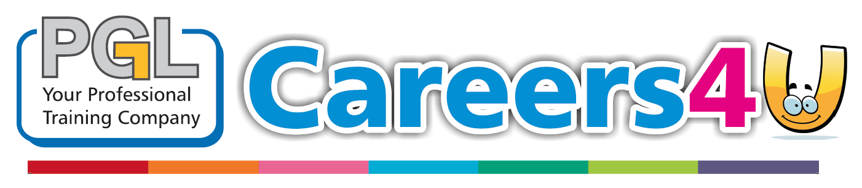

**COMMERCIAL COURSES**

**November 2018**

**NEWSLETTER**

**APPRENTICESHIP WAGE ALERT**

January 2018

**MONTHLY NEWSLETTER**

**Following on from our busiest ever year of Domestic and Commercial Gas and Oil courses, it was great to have such a successful audit this week from our certification body ERS. Thank you to all our loyal customers who continue to support us year after year and also to Paul and his team.**

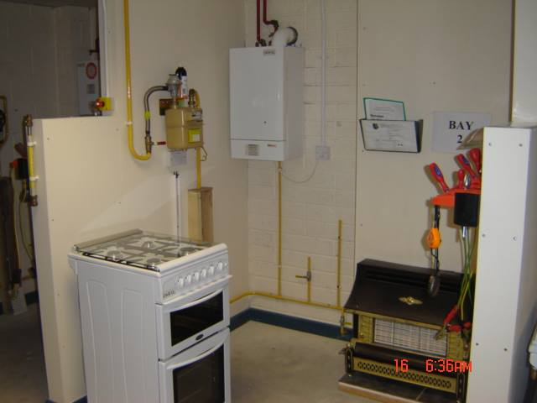

**For more information or to book any of our courses please contact Colin on 01392 437373.**

**The apprenticeship minimum wage will be increasing from £3.70 to £3.90 from April 2018. This is fantastic news for all Apprentices in the first year of their qualification. For more information please visit-**[**https://www.google.co.uk/…/budget-2018-apprentice-**mini…/amp/](https://l.facebook.com/l.php?u=https%3A%2F%2Fwww.google.co.uk%2Famp%2Fs%2Ffeweek.co.uk%2F2018%2F10%2F29%2Fbudget-2018-apprentice-minimum-wage-set-to-rise-again%2Famp%2F%3Ffbclid%3DIwAR2GwF4I5nR29S5lUfaIcbUzS6v7lZ5dqdHUk-tAxGjhUP_M3UhwmrE6P00&h=AT2Mx2vNUhlNJtz6UnjzPNWHXTmXM5IpfOGnSAqXtNaXbarUP6UXiY-Y0Iuwke-Vvn4qJM6yNve5hC53HvN6U5Q3GkWSg4hYK-3Uj71IZWCV61zh-SOGQu52YM1cKqEB_9gZ_3QgkjRrDV2y0w3LMG4uEEXugCOHaFGZWuUQ-IpU0KiIDib9zNo9HATQvUCdR7S0hnTGnLeEOkj3c5e27-9hashN5IEuogk4_TwEzHuVbbfULA9o0038pIbr_CFHhEzQsFXFYNmU7aDdGnJfAAcGIvFLldOvhFUr78WvTjbs1q7u_gFythRWvPCVYyQTp1QzAjCCihuzmcy-ThlLzwTcBp9mtPGxc7BdXftxwNF4XYcTjda3ztMIp1uDnQC95OMD8Z_6oNiBWpXggSVp_drVElJX2lDFwvsESV0BSE4QT4SXpKqNEdne8K1LSDSDCLmxyLsrhjYINwLbuiknzoqu-kQprRCsuMdQSSeJPBh20KNEPT2IBX_FsvHuypsA2yOg4yoXaAapBlRBTtQV-VK_W0glDfjI3dqfnv5axyIq9LEW9Q8f9_ZmD6Mdm1PfbP6JinNtTYSoh46HThiSDWYaD9Zsy_U55_HUUHObxbEjMD_fgwLEJvA5mBlE3cozmfZc)



**From November PGL Training will be offering a First Aid course in our Fore Street premises to our employers and learners. The qualification is a one day course which provides you with an Emergency First Aid Level 3 qualification. With dates across the year please contact Alberto Pitocco for more information or to book a place- 01392 537561.**

**BLACK TIE EVENT 29/03/2019**

**PGL Training are hosting a black tie awards evening on March 29th 2019, where we will be celebrating success from the past year. PGL aims to achieve a grand total of £5,000 on the night to go towards our target of £20,000 for MIND Charity.**

**With over 150 tickets already sold, don’t miss out. Get in touch today to reserve your space at our spectacular awards evening. Tickets available on a first come first served basis. Please contact Natalie Blowers, our Fore Street Administrator for more information- 01392 537561**

**A Traineeship is an education and training programme with work experience that is focused on giving you the skills and experience that employers are looking for. At its core is work preparation, English and Maths training for those who need it and a high quality work experience placement. With PGL Training you can complete a Traineeship in Construction, Electrical, Business Admin, and Hairdressing and Beauty sectors. For more information please contact Alberto Pitocco on 01392 537561.**

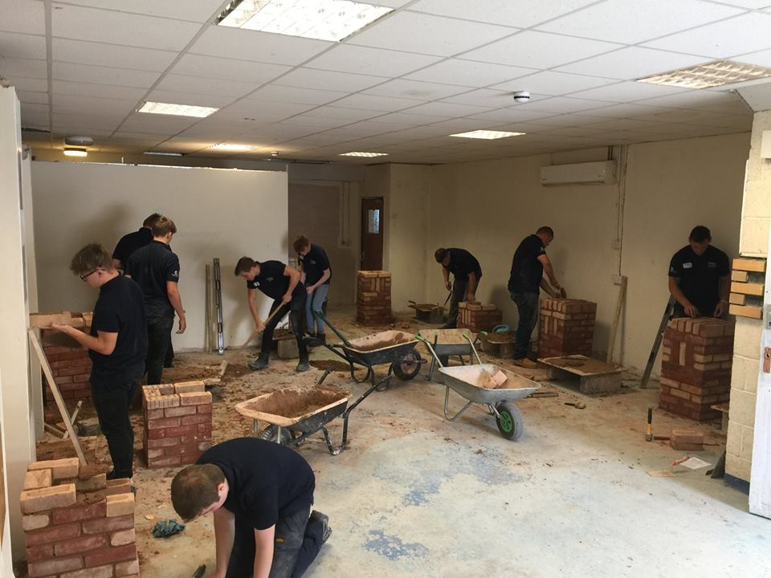****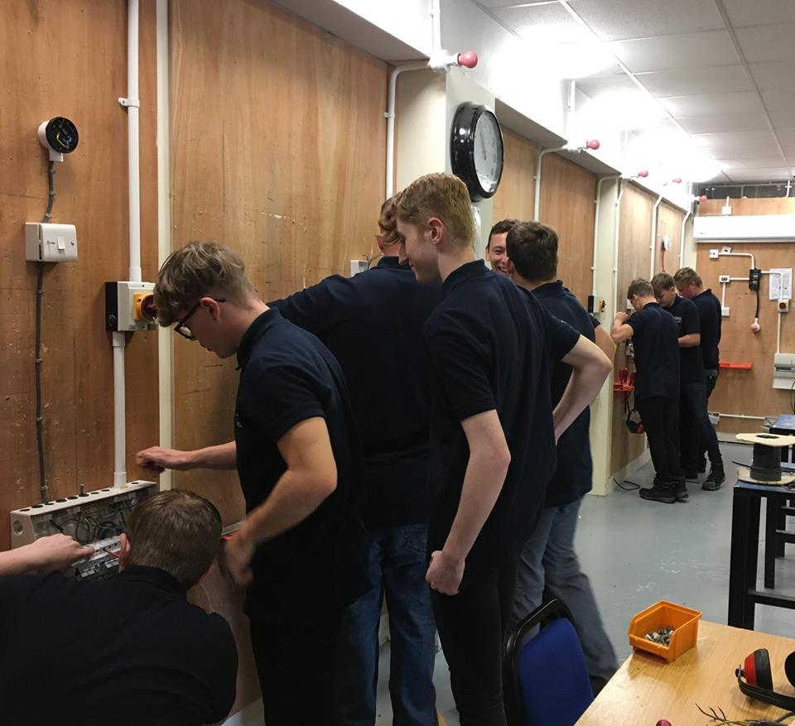

**PGL Training had an amazing Open Day on Wednesday 28th November 2018 with a number of applicants attending the event. The open day gave applicants the opportunity to ask questions about our courses and for them to attend our trade workshops in construction, electrical, plumbing and business admin. If you would like to find out more information regarding an Apprenticeship or Traineeship please contact the Recruitment Team today on 01392 537561.**

**FIRST AID (FORE STREET)**

**TRAINEESHIP COURSE 16-24 (PGL TRAINING)**

**OPEN DAY SUCCESS**